TECHNICAL DESIGN DOCUMENT

16 JULY 2025

LEARning management system FOR SYS college

**zohaib waqar**

ex dev & Technical business analyst

Table of Contents

**Document Overview2**

**System Architecture2**

**Glossary3**

**Functional Requirements3**

User Management3

Course Management3

Student Enrollment & Scheduling4

Content Delivery & Interaction4

Assignment & Grading Workflow4

Dashboards & Analytics5

Compliance & Reporting5

**User Roles & Permissions6**

**UI Behavior and Validation Rules6**

User Management (Register/Login)6

Course Management7

Enrollment & Scheduling7

Content Delivery & Access7

Assignment & Assessment8

Analytics & Reporting8

**Business Rules8**

**Non-Functional Requirements9**

**Assumptions and Dependencies9**

**Appendices10**

1. **Document Overview**
   1. **Purpose**

This document outlines the technical architecture, integration components, database design, and system flow for the LMS platform at Sys College. It is intended for developers, architects, system administrators, and technical project managers.

* 1. **Scope**

Covers internal system components, data flow, integration with external systems (SIS, Active Directory, Turnitin), and APIs.

1. **System Architecture**
   1. **Architecture Style.** Modular, service-oriented architecture (SOA) with RESTful APIs
   2. **Deployment.** Cloud-based (e.g., AWS / Azure)
   3. **Layers**

* **Presentation Layer.** Web interface (React), mobile-responsive
* **Application Layer.** Node.js or Django backend
* **Data Layer.** PostgreSQL or MySQL database
* **Integration Layer.** REST APIs, Webhooks, Middleware
  1. **Authentication**
* SSO via Active Directory
* Role-Based Access Control (RBAC)
* Multi-Factor Authentication (MFA)

1. **Key Modules & Components**
   1. User Management (UM)
   2. Course Management (CM)
   3. Content Delivery (CD)
   4. Assignment & Assessment (AA)
   5. Enrollment & Scheduling (ES)
   6. Analytics & Reporting (AR)
   7. Compliance & Auditing (RP)
2. **Integration Overview**
   1. **External Systems**

* **Active Directory.** SSO and role management.
* **SIS.** Sync student/course/enrollment data.
* **Turnitin API.** Check plagiarism on submission event.

1. **Security Considerations**
   1. All traffic over HTTPS
   2. Token-based auth (JWT)
   3. Encrypted file storage (assignments, content)
   4. Secure API gateway (rate-limiting, audit logging)
2. **Scalability Plan**
   1. Horizontal scaling using container orchestration (Kubernetes)
   2. Load balancers to distribute traffic
   3. Caching (Redis) for high-frequency reads (e.g., course listings)
   4. Asynchronous job processing for report generation & Turnitin checks
3. **Error Handling & Logging**
   1. Centralized logging (e.g., ELK Stack)
   2. Standard HTTP error codes with custom error payloads
   3. Notification alerts for API failures or job errors (Slack/email)
4. **Appendices**
   1. [Requirements Elicitation Document (dated: 03 May 2025)](https://github.com/ZohaibWaqarMalik/Technical-Business-Analyst-Projects/blob/main/02%20-%20LMS-SysCollege/01%20-%20Requirements%20Elicitation/01%20-%20Requirement%20Elicitation.pdf)
   2. [Stakeholder Interview Summaries (dated: 05 May 2025)](https://github.com/ZohaibWaqarMalik/Technical-Business-Analyst-Projects/blob/main/02%20-%20LMS-SysCollege/01%20-%20Requirements%20Elicitation/02%20-%20Requirements%20Elicitation%20-%20Questionaries.pdf)
   3. Appendix A: Wireframe User Registration
   4. Appendix B: Wireframe User Login
   5. Appendix C: Wireframe Course Management
   6. Appendix D: Wireframe Student Enrollment
   7. Appendix E: Wireframe Course Schedule
   8. Appendix F: Wireframe Content Delivery and Integration
   9. Appendix G: Wireframe Assignment and Grading
   10. Appendix H: Wireframe Dashboard Analytics
   11. Appendix I: Wireframe Compliance and Reporting

**Appendix A**

**WIREFRAME: USER REGISTRATION**

Fig A1: Wireframe User Registration

This wireframe illustrates the registration form layout, including validation fields, and account setup options for new LMS users.

**Appendix B**

**WIREFRAME: USER LOGIN**

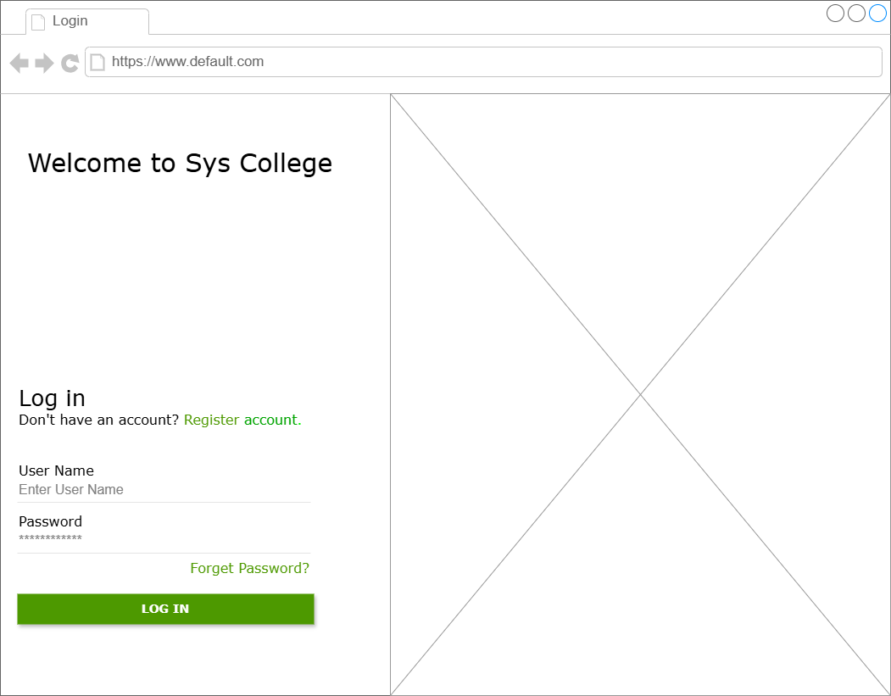

Fig B1: Wireframe User Login

This wireframe displays the login interface, including credential input fields and secure authentication via institutional SSO.

**Appendix C**

**WIREFRAME: COURSE MANAGEMENT**

Fig C1: Wireframe Course Management

This wireframe outlines the faculty interface for creating and managing course information, including title, code, and description. It also supports module-wise content uploads (e.g., PDFs, videos) and provides full CRUD (Create, Read, Update, Delete) functionality for modules and assignments.

**Appendix D**

**WIREFRAME: STUDENT ENROLLMENT**

Fig D1: Wireframe Student Enrollment

This wireframe illustrates the enrollment interface for admin staff, for importing student information from SIS or manually adding new student including fields for Student ID, Name, Enrollment Type, and document upload for verification or transfer processing.

**Appendix E**

**WIREFRAME: COURSE SCHEDULE**

Fig E1: Wireframe Student Enrollment

This wireframe presents the interface for scheduling courses, including fields for course code, assigned faculty, start and end dates, time slots, and conflict checks.

**Appendix F**

**WIREFRAME: CONTENT DELIVERY AND INTEGRATION**

Fig F1: Wireframe Student Enrollment

This wireframe illustrates the student interface for selecting courses and modules, viewing associated content and assignments, and downloading learning materials for offline access.

**Appendix G**

**WIREFRAME: ASSIGNMENT AND GRADING FLOW**

Fig G1: Wireframe Student Enrollment

This wireframe shows the faculty interface for selecting a course and module, viewing student submissions with timestamps and plagiarism reports, and assigning grades with comments and feedback for each student.

**Appendix H**

**WIREFRAME: DASHBOARD AND ANALYTICS**

Fig H1: Wireframe Student Enrollment

**Appendix I**

**WIREFRAME: COMPLIANCE AND REPORTING**

Fig I1: Wireframe Student Enrollment